# MMP 350 CSS Exercises, Week 1 Class 2

## Table of contents

MMP 350 CSS Exercises, Week 1 Class 2 1

Table of contents 1

Note on Text Conventions 1

Instructions 1

Exercise 1: Inheritance and Styling Conflicts in CSS 1

Purpose 1

Concepts 2

Steps 2

Exercise 2: Four ways of selecting in CSS 5

Purpose 5

Concepts 5

Steps 5

Exercise 3: Positioning and flow 8

Purpose 8

Steps 8

Exercise 4: Margins and Padding 12

Purpose 12

Steps 12

## Note on Text Conventions

I display html elements in the text as follows: <div> <span> etc. Note that when talking in the plural I will write something like, *the three <divs> have all turned green.* HTML elements are never plural. I use this convention because <div>s looks ugly.

## Instructions

Work through the following exercises. Within the exercises are questions followed by the phrase Your Answer. Please fill in your best guess as to what the answer is. When done with the exercise please email this document *with your answers* to me at [brianmacmillanteacher@gmail.com](mailto:brianmacmillanteacher@gmail.com)

## Exercise 1: Inheritance and Styling Conflicts in CSS

### Purpose

* To demonstrate how cascading style sheets handle conflicts between elements, classes and element ids.
* To introduce students to some useful selection tips

### Concepts

* Inheritance / cascading styles
* Serif and sans serif fonts. Sans-serif fonts are characterized by even line weights. They are typically used for headlines. Examples are Helvetica and Arial. Serif fonts have uneven stroke widths, characterized by serifs (nodes) at the end of strokes. They are typically used for body text because the serifs make the characters easier to read. Common examples are Times Roman and Booker.

### Steps

1. Create a folder called Exercise 1
2. Open a browser in Private Browsing / Incognito mode. This is done to avoid caching issues by the browser.
3. 3. Create a file called exercise_cascading_stylesheets.html with the following attributes or use a copy provided by the Professor.

<!DOCTYPE html>

<html>

<head>

<meta charset="utf-8">

<title>Simple Cascading Example</title>

<link href="style_cascading.css" rel="stylesheet">

</head>

<body>

<div id="main">

<header class="header">Header</header>

<section>

<p class="body-text">Paragraph One</p>

<p class="">Paragraph Two</p>

<p class="">Paragraph Three</p>

<p id="last-paragraph" class=“”>Paragraph Four</p>

<div id="child-container" class="child-text">

<p class="">Child paragraph</p>

<div>

<p id="grandchild">Grandchild paragraph</p>

</div>

</div>

</section>

<footer>Footer</footer>

</div>

</body>

</html>

4. Create a file called *style_cascading.css* with the following content:

html{margin:10px;}

body {color:red;margin:0;padding:0;font-size:32pt;font-family:sans-serif;}

.child-text{color:black;}

You will see the following:

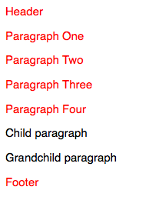

*Q: Why is some text black and some text red?*

A: Body creates a default color of red which is inherited. This setting is overridden for elements with the class .child-text.

5. Add the following to your style sheet.

p{font-family:serif;}

Notice that all of the p elements are now in a serif font.

6. Make the font family for *.child-text* sans-serif

.child-text{color:black;font-family:sans-serif;}

*Q: Why did the child and grandchild paragraphs not become sans serif?*

A: In css styling conflicts are resolved from the most general to the most specific. In this case the style information inherited from div#child-container was overridden by the default styling set in the body element

7. Now add the *child-text* class to the Child paragraph and the Grandchild paragraph and refresh your page.

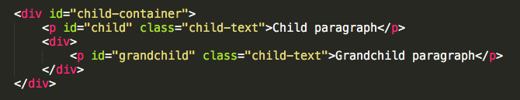

*Q: Why did the child and grandchild paragraphs become sans-serif?*

A: Because the child-text class was added directly to the child and grandchild paragraphs. This overrides the styling these elements inherited from the <body> element.

8. Now add the following to the bottom of your css file:

#grandchild{font-family:serif;}

The file should look like the following:

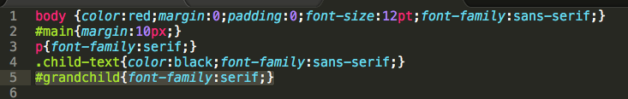

There are now two conflicting styles applied to the grandchild element, one applied via the classname *.child-text*, the other applied via the style for element id #grandchild

*Q: Why did the grandchild element become serif?*

A: Because the id style for #grandchild is more specific than inherited styles and class styles.

9. Now add a second class called *quote* to the #grandchild element in the html document. The result should look like the following. The word quote is in red for emphasis. In your html document it will not change color.

<div>

<p id="grandchild" class="child-text quote">Grandchild</p>

</div>

... and add a class definition for quote to the style sheet:

.quote{margin:20px}

Note how two different classes can be applied to the same element. But what happens when there is a conflict?

10. Modify the *.quote* class as follows:

.quote{margin:20px;font-style:italic;color:purple;}

There is now a clash between the two classes. The *.child-text* class specifies a color of red and the *.quote* class specifies a color of purple. Which one wins? That depends on the position of the two classes in the file.

11. Change the position of the two classes in your css file, first with *.child-text* before *.quote*

.child-text{color:black;font-family:sans-serif;}

.quote{margin:20px;font-style:italic;color:purple;}

… and then with *.quote* before *.child-text*

.quote{margin:20px;font-style:italic;color:purple;}

.child-text{color:black;font-family:sans-serif;}

*Q: What happens?*  
A: In situations where two styles are equally specific, the last style overrides earlier ones.

12. Make Grandchild sans-serif.

This is trickier than it sounds because there are now three different stylings applied to the grandchild paragraph font-family, with body, .child-text and #grandchild styles. Deciding which solution to use has consequences.

## Exercise 2: Four ways of selecting in CSS

### Purpose

CSS has many useful techniques that to allow you to apply styles to objects, based on their position in the DOM object hierarchy. This exercise looks at four techniques.

### Concepts

Pseudo Classes

### Steps

1. Create a document called style_selection.html with the following content

<!DOCTYPE html>

<html>

<head>

<meta charset="utf-8">

<title>Simple Cascading Example</title>

<link href="style_selection.css" rel="stylesheet">

</head>

<body>

<div id="main">

<header class="header">Header</header>

<section>

<p class="body-text">Paragraph One</p>

<p class="">Paragraph Two</p>

<p class="">Paragraph Three</p>

<p id="last-paragraph" class="">Paragraph Four</p>

<div id="child-container" class="child-text">

<p class="child-text">Child paragraph</p>

<div>

<p id="grandchild" class="child-text quote">Grandchild paragraph</p>

</div>

</div>

</section>

<footer>Footer</footer>

</div>

</body>

</html>

2. Create a style sheet called *style_selection.css* in the same folder as your html document and add the following styles:

body {color:red;margin:0;padding:0;font-size:12pt;font-family:sans-serif !important;}

#main{margin:10px;}

Save and view the file. It should look like the following:

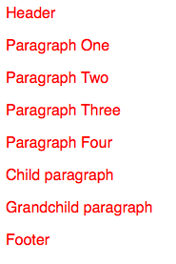

3. Add the following to your css file

section p {color: blue;}

*Q: What happened?*

A: All paragraphs that are children of <section> turn blue.

4. Change the styling as follows:

section > p {color: blue;}

*Q: What has happened?*

A: Only the elements immediately below <section> had the styling applied.

5. Add the following to the bottom of your file:

section p:first-child{color: green;}

*:first-child* is known as a psuedo class. There are a number of pseudo classes including *:hover*, *:before*, *:after*, *:first-letter* and *:first-line*

*Q: Why did 3 paragraphs turn green?*

A: Paragraph One, Child Paragraph and Grandchild Paragraph are all first children.

6. Change what you just typed by adding a **>**

section **>** p:first-child{color: green;}

*Q: Why did only the first paragraph turn green?*

A: The > operator selects the immediate children of the element or class in the style, in this case the *section* element.

1. Add the following to your css file:

section > p:first-child:first-letter{font-weight:bold}

Notice that pseudo classes can be added together.

## Exercise 3 - Positioning and flow

### Purpose

* To demonstrate the difference between fixed, absolute, floating and static positioning
* To demonstrate the difference between inline, block and inline-block styles

### Steps

1. Create a document called positioning_exercise.html

<!DOCTYPE html>

<html>

<head>

<meta charset="utf-8">

<title>Positioning Example</title>

<link href="style_positioning.css" rel="stylesheet">

</head>

<body>

<header class="myheader">This is a header.</header>

<h2>Position Static and Position Relative</h2>

<section id="s1">

<div>These divs</divs>

<div>have no positioning information</div>

<div>so default to position static. This means they render basedon their position in the document flow.</div>

</section>

<section id="s2">

<div class="pr">When these divs</div>

<div class="pr">are

<span class="red">position relative</span>, they align relative to their parent container, in this case section.s2.

</div>

</section>

<footer class="myfooter">This is a footer.</footer>

</body>

</html>

2. Create a style sheet called *style_positioning.css* and save it to the same location as positioning_demo.html

body{height:1100px;border: 1px solid red;}

View the results in a browser. They should look like the following. At this point, make your browser window smaller so that it has a vertical scrollbar.

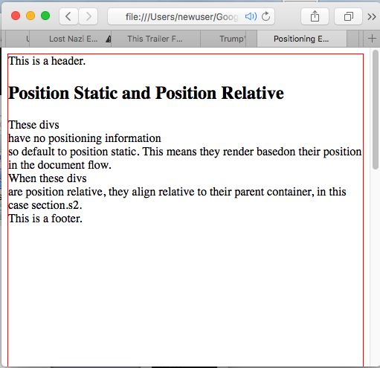

3. Make the header fixed by adding the following class to your style sheet

.myheader{position:fixed;}

Scroll up and down to see the results of your change.

4. Position the footer at the bottom of the screen by adding the following to the css:

.myfooter{position:fixed;bottom:10px;}

5. Now give the footer an absolute position:

.myfooter{position:absolute;bottom:10px;}

Scroll up and down to see the results of your change.

*Q: The footer, when given an absolute position behaves differently when you scroll then when it has a fixed position. Describe this difference*

A: The element has been moved to the bottom of the document, but it flows with the document. Fixed elements do not flow with the document.

6. Position static and relative

Add the following class to the style sheet

.pr{position:relative;}

This styling with be will be applied to the first and second divs of the section#s2:

<section id=”s2”>

<div class="pr">These divs</div>

<div class="pr">are

<span class="red">position relative</span>, so are aligned relative to the parent container

</div>

</section>

Refresh your screen. Nothing should happen. Making the above two divs *position:relative* renders the document no differently than before when they defaulted to *position:static*.

8. Now add the following to the *.pr* class

.pr{position:relative;left:100px}

When you refresh notice how the two <divs> with the .pr class are now offset by 100 pixels.

*Q: what are the div.pr elements moving relative to when their left property is set?*

A: Their parent container. Demonstrate this using margins and borders.

8. Now change the .pr class style as follows:

.pr{position:static;left:100px}

*Q: Why did the two div.pr elements stop indenting?*

A: Because static elements do not have a left, right, top or bottom property. They simply flow in the document.

9. Block, Inline and Inline-Block

Look at the rendered version of the document and then its source, focusing on the two sections. Notice how the document has line breaks where-ever there are <divs> but does not when there are <spans>. That is because <divs> are block elements and <spans> are inline elements. That means that divs have breaks before and after themselves; while spans can be placed within a line of text.

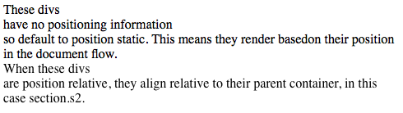

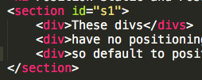

*Figure: Note the break after <div>These divs</div>. This happens because <divs> are block elements.*

10. The *display:inline-block* styling merges these two elements. Add the following to your style sheet:

section div {display:inline-block}

*Q: What happens when you refresh your page?*

A: The breaks associated with <divs> are gone because the <divs> are acting like inline elements

11. Setting height and line height to show the difference between inline-block and inline.

Spans are inline elements. Add the following styling so we can easily see the spans

.red{color:red}

When you refresh, you will see that span.red has become red. It is an inline element so it flows within the line.

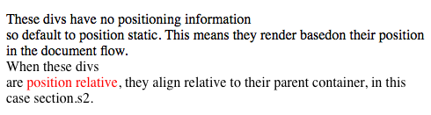

12. Set the line-height of the spans

span {line-height: 68px;}

12. Try to set the height property

span {height: 68px;}

*Q: Height is ignored. Why?*

A: Inline elements do not have a height property

13. Make the spans block elements:

span {display:block;height: 68px;}

When the span is made into a block element it gets a height property.

14. What is the difference between height and inline height?

Give your spans a border and then view them first with line-height set and then with height property set (not both at the same time)

span {display:block;line-height: 68px;border:1px solid purple;}

span {display:block;height: 68px;border:1px solid purple;}

*Q: How does the text position change based on height and line-height properties?*

A: Text is centered vertically when you only use line-height property, and moves to the top of the element when you only set the height property.

15. Extra work

Make the div.pr elements inline-block and play with both their line-height and height properties simultaneously to see what happens.

## Exercise 4 - Margins and Padding

### Purpose

To demonstrate the difference between margins and padding

### Steps

1. Create a document called *padding_and_margins.html* and add the following code to it:

<!DOCTYPE html>

<html>

<head>

<meta charset="utf-8">

<title>Padding and Margins Example</title>

<link href="style_margins_and_padding.css" rel="stylesheet">

</head>

<body>

<section>

<h2>Padding and Margin Example</h2>

<div id="outer" class="border">Outer

<div id="middle" class="border">Middle

<div id="inner" class="border">Inner</div>

</div>

</div>

</section>

</body>

</html>

2. In the same folder create a file called *style_margins_and_padding.css* and add the following styles:

#outer{border:2px solid blue;}

#middle{border:2px solid red;}

#inner{border:2px solid green;}

The results should look like the following:

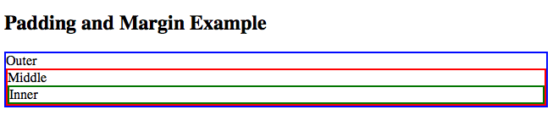

3. Add the following style to the #inner element

#inner{border:2px solid green;margin:10px 10px 10px 10px}

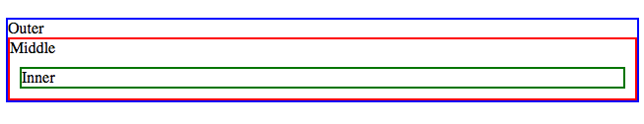

*Q: What happened?*

A: The space around the top, right, left and bottom of the element got a margin of 10 pixels

4. Add the following style to the #middle element

#middle{border:2px solid red;margin:10px 10px;}

*Q: What happened?*

A: The space around the top, right, left and bottom of the element got a margin of 10 pixels

5. Add the following style to the #outer element

#outer{border:2px solid blue;margin:10px;}

*Q: What happened?*

A: The space around the top, right, left and bottom of the element got a margin of 10 pixels

6. Change the styling associated the #inner element to the following:

#inner{border:2px solid green;margin:10px 20px 30px 40px;}

*Q: What happened?*

A: The top of the element got 10 pixels of space added outside, the right of the element got 20px of space added outside the element, the bottom of the element got 30px of space added below it, and 40px of space was added to the left of the element.

7. Change the styling associated the #inner element to the following:

#inner{border:2px solid green;margin:10px;padding:10px}

*Q: What happened?*

A: 20px of space added around the outside of the element (margin), 10px of space added within the element (padding).

8. Change the style for #outer as follows:

#outer{border:2px solid blue;margin:-50px 10px 10px 10px;}

*Q: What happened?*

A: div#outer moved up by 50 pixels because it has a negative margin.

9. Make #outer position fixed, relative and absolute

Q: What happened? With *position: fixed* the width of the element shrunk based on text size, instead of defaulting to screen width;

10. Make all three elements *position:fixed*

#outer{position:fixed;border:2px solid blue;margin:10px;}

#middle{position:fixed;border:2px solid red;margin:10px;}

#inner{position:fixed;border:2px solid green;margin:10px;}

When you refresh you should see the following:

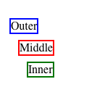

*Q: What happened?*

A: Because all three elements are no longer in the document flow they are no longer nested. The point of this example is that properties like position and margin interfact with each other.